**Real Time Processing Example**

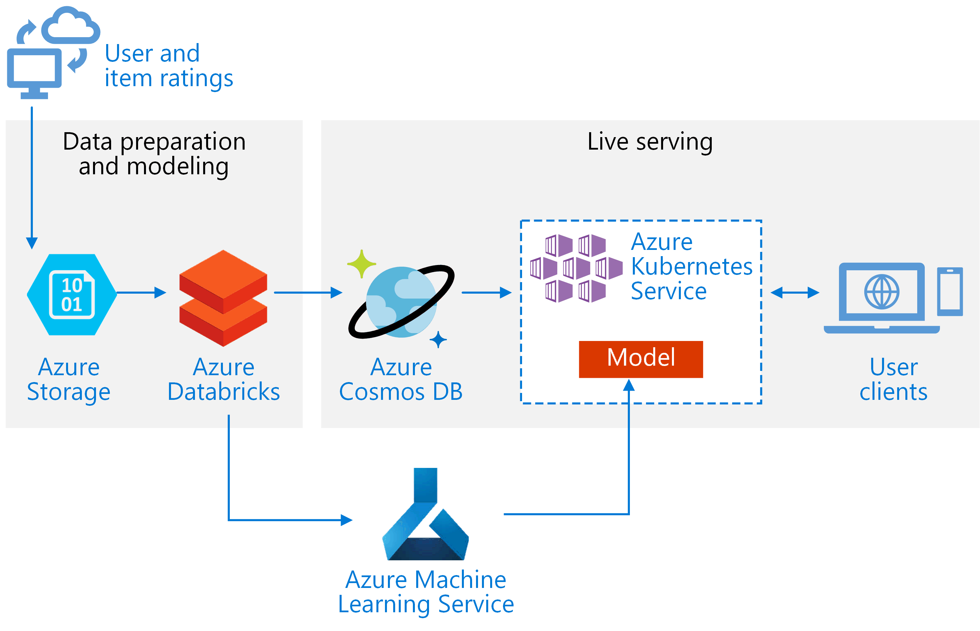

<https://docs.microsoft.com/en-us/azure/architecture/reference-architectures/ai/real-time-recommendation>